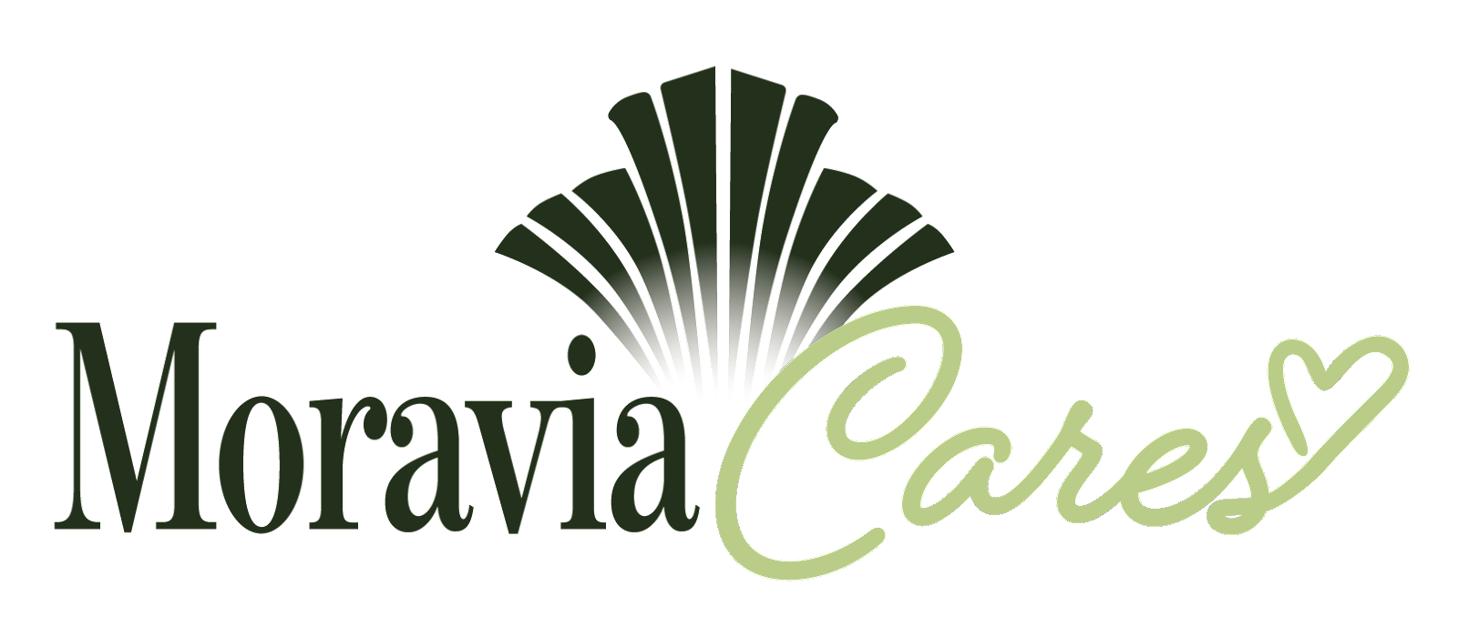

MORAVIA CARES VOLUNTEER APPLICATION

Contact Information

Name Date:

Address

City State Zip Code:

Phone

Email

Date of Birth

SS#

Valid Driver’s License: 〇 YES 〇 NO

Emergency Contact Information

Name

Relationship

Phone

(Address) (City) (State) (Zip Code)

What is your availability to volunteer?
〇 Monday Hours_________________ Start Date:______________
〇 Tuesday Hours_________________
〇 Wednesday Hours______________ Hours Needed:__________
〇 Thursday Hours________________
〇 Friday Hours___________________ Completion Date:________
〇 Saturday Hours_________________
〇 Sunday Hours__________________

How did you hear about Moravia Cares?

Why are you interested in volunteering for Moravia Cares?

Previous volunteer experience:

Volunteer Location:

〇 Philadelphia 〇 Harrisburg 〇 Pittsburgh 〇 Eerie
〇 Scranton 〇 Wilkes Barre 〇 Reading 〇 Lancaster

What languages do you speak?___________________________________________

Are you able to perform essential duties of the volunteer job for which you are applying? 〇 Yes 〇 No
If no, please explain______________________________________________________
(Note: A disability will not prevent you from volunteering if you are able to perform the essential duties of the job with reasonable accommodations.)

Do you have any transportation barriers to consider? 〇 Yes 〇 No
If yes, please describe____________________________________________________

Equal Employment Opportunity
Note: We are requesting EEO information on a voluntary basis. The purpose of requesting this information is to monitor our effectiveness in attracting minorities. The information collected is confidential. Please check how you would designate yourself racially and/or culturally:

Are you of Hispanic origin? (This is defined as being a person of Mexican, Puerto Rican, Cuban, South American or other Spanish Culture or origin, regardless of race?)
〇 Yes 〇 No
Race:
〇 African American
〇 Asian or Pacific Islander- a person with origins in any of the original peoples of the Far East, Southeast Asia, the Indian subcontinent, or the Pacific Islands.
〇 Caucasion
〇 Native American
〇 Multicultural- a person that would classify themselves as more than one of the above
Note: Because of the sensitive nature of our work, we request the following information:

- Have you been convicted of a crime?
〇 Yes 〇 No
If yes, please explain when, where and the nature of the offense below:

- Are there any criminal charges against you currently?
〇 Yes 〇 No
If yes, please explain when, where and the nature of the offense below:

- Are there any criminal charges against you currently?
〇 Yes 〇 No
If yes, please explain when, where and the nature of the offense below:

- Are there any criminal charges against you currently?
〇 Yes 〇 No
If yes, please explain when, where and the nature of the offense below:

- Have you ever had a personal order of protection against you?
〇 Yes 〇 No
If yes, please explain when, where and the nature of the offense below:

- Have you ever been involved with abuse or neglect of a child or adult?
〇 Yes 〇 No
If yes, please explain when, where and the nature of the offense below:

- Have you ever been involved with a protective service agency?
〇 Yes 〇 No
If yes, please explain when, where and the nature of the offense below:

- Have you ever been involved with a protective service agency?
〇 Yes 〇 No
If yes, please explain when, where and the nature of the offense below:

Volunteer Applicants Statement:

I understand it is my responsibility to share client information only with staff involved, to keep all information confidential and to report any information which may impact clients and/or co-workers.

I certify that this volunteer application is a complete record and that all entries and attachments are true and accurate to the best of my knowledge.

Volunteer Applicant Signature: Date:

If volunteer is less than 18 years of age:

Parent/Guardian’s Signature: Date:

Parent/Guardian’s Phone:________________________ Email:_______________________

Participation Release of Liability and Assumption of Risk Agreement
***Read Entire Page Before Signing –
Please Print***

Name of Activity/Program: ___________________________________________
Location:______________________________________Fiscal Year: 20___ ‐20___
Participant Name: Email:

In consideration of being allowed to participate in any way in the program, related events and activities, I, the undersigned, acknowledge, appreciate and agree that:

1. The risk of injury from the activities involved in this program/activity may be significant, including the potential for permanent paralysis and/or death.

2. I KNOWINGLY AND FREELY ASSUME ALL SUCH RISKS and assume full responsibility for my participation.

3. I willingly agree to comply with all terms and conditions for participation. I will comply with all safety policies and procedures. If I observe any hazard during my presence or participation, I will remove myself from participation and bring such information to the attention of the nearest supervisor immediately.

4. I, for myself and on behalf of my heirs, assigns, personal representatives and next of kin, HEREBY RELEASE, INDEMNIFY, AND HOLD HARMLESS Moravia Cares, its officers, officials, agents and/or employees, other participants, sponsors and its officers, agents, servants and employees, advertisers and, if applicable, owners and lessors of premises used to conduct the event (“Releasees”) from any and all claims, demands, losses and liability arising out of, or related to, any INJURY, DISABILITY OR DEATH I may suffer, or loss or damage to person or property, to the fullest extent permitted by law.

5. In the case of a life-threatening or serious accident or illness, I (parent or guardian), if applicable, ask that Moravia Cares contact me. In such a case, I give permission for a rescue squad to transport my child to the closest medical facility. Should this occur, I give permission for the medical facility to treat my child at my expense.

6. In the case of a life-threatening or serious accident or illness, I give permission for a rescue squad to transport me to the closest medical facility. Should this occur, I give permission for the medical facility to treat me at my expense.

7. I give permission for me or my child (if applicable) to be videotaped or photographed while participating in the program or activity, and I give permission for Moravia Cares to use the videotape and/or photographs in brochures, newspaper articles, on the County’s website, Facebook, Twitter on Public Television and in other local media outlets.

I HAVE READ THIS RELEASE OF LIABILITY AND ASSUMPTION OF RISK AGREEMENT, I FULLY UNDERSTAND ITS TERMS, AND I UNDERSTAND THAT I GIVE UP SUBSTANTIAL RIGHTS BY SIGNING IT, AND SIGN IT FREELY AND VOLUNTARILY WITHOUT ANY INDUCEMENT.

Volunteer Participant’s Signature:

Date:

For PARENTS/GUARDIANS of PARTICIPANT of MINOR AGE (under age 18 at time of participation):
This is to certify that I, __________________________________, as parent/guardian with legal responsibility for this participant, do consent and agree to his/her release of all Releasees, as provided above of, and, for myself, my heirs, assigns and next of kin, I release and agree to indemnify and hold harmless the Releasees from any and all liability incident to my minor child’s involvement or participation in this program/activity as provided above to the fullest extent permitted by law.

Parent/Guardian Signature

Emergency Phone Number(s)

Date

